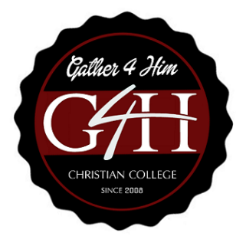

Institutional Effectiveness Report 2018-2019

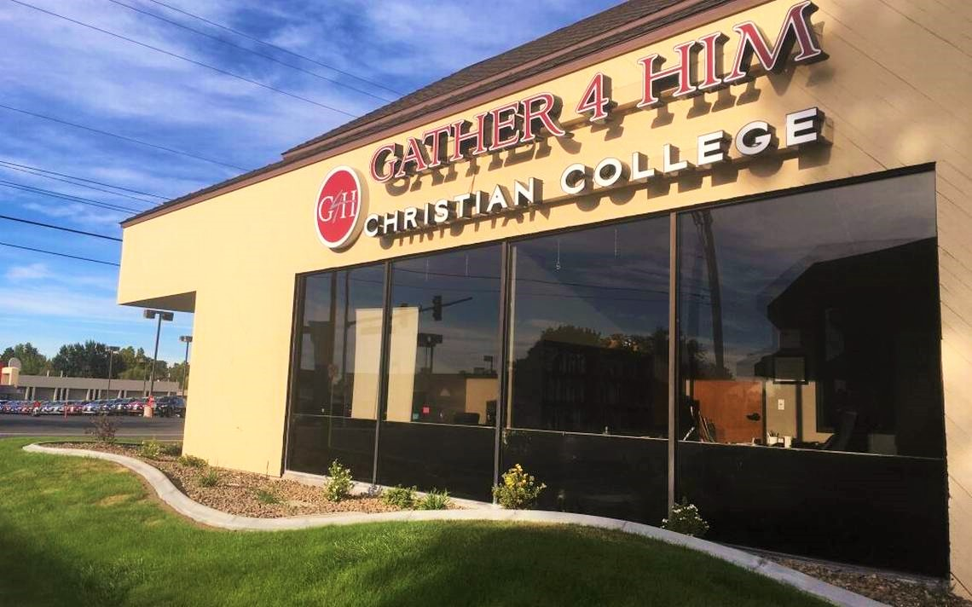

September 27, 2019

Contents
Introduction 2
Purpose of This Report 4
Governance 5
Process for Improvement 5
Institutional Accomplishments for FY 2019 6
Academics 6
Retention and Completion Rates 6
Faculty Initiative to Improve Retention and Completion Action Project 7
Student Course Evaluations and Student Satisfaction Surveys 7
Alumni Satisfaction 8
Strategic Goals 2019 9
Strategic Goal 1: ACCREDITATION: 9
Strategic Goal 2: STUDENT ENROLLMENT. 9
Strategic Goal 3: FACULTY AND STAFF. 9
Strategic Goal 4: FINANCIAL SUSTAINABILITY. 10
Strategic Goal 5: CAMPUS FACILITIES. 10
Strategic Goal 6: INFORMATION TECHNOLOGY. 10
Strategic Goal 7: BOARD GOVERNANCE. 10
ACCOMPLISHMENTS 11
Institutional Issues of Note 12
INSTITUTIONAL ACTION PLAN 13
TRACS Accreditation 13
Strategic Goals and College Priorities 14
REQUESTS FOR ADDITIONAL RESOURCES 14
Future academic goals 15

Introduction

Dear G4H Community,
I am pleased to share the college’s Institutional Effectiveness Report (IER) for fiscal year 2018. The plan tracks recent progress, presents future plans, and proposes recommendations for action to the Senior Leadership Team and myself through data collected from all college programs and departments.
Most importantly, the Institutional Effectiveness Report promotes a continuous quality improvement process. Our Annual Program Update allows each area of the college to chart their successes and their resource needs. This information is integrated into the final Institutional Effectiveness Report, which provides a comprehensive approach to college planning and reporting as it supports the college’s decision-making processes related to strategic, financial, facilities master planning, and project prioritization.
Additionally, the Institutional Effectiveness Report produces a streamlined approach to developing, managing, and tracking accreditation projects and collecting their results, a requirement for accreditation with the Transnational Association of Christian Colleges and Schools.
My sincere appreciation is extended to everyone for their contributions to this plan. Due to their hard work and diligence, the college has a way to document the needs of its programs and incorporate them into organized priorities and future successes.

Sincerely,

Robert N. Nash President
January 16, 2019

This page left blank

Purpose of This Report
The purpose of the Gather 4 Him Christian College Institutional Effectiveness Report (IER) is to clarify and provide input to the college’s decision-making processes related to strategic planning, budgeting, and project prioritization through the collection of program data and information, and through the establishment of a transparent evaluative process as the collected information is reviewed at the program and college levels. It is a comprehensive look at all aspects of college functions, both academic and support services, through which we align actions to the college’s mission and strategic goals.
The Institutional Effectiveness Report is an internal report prepared annually and used to identify institution level operational and personnel priorities and goals. It directs institutional activities toward strategic goals based on annual evaluations that measure meaningful outcomes at all college unit/program, division, and institution levels. This data-based information is collected each year. While the IER informs yearly budget decisions, those budget decisions are not an automated process nor does inclusion in the IER equal funding approval. The completion of the IER does assist the units/programs in preparing funding requests to submit via the institution’s Financial Planning process.
In addition, the process established for program improvement will assist the college in fulfilling external reporting requirements with the Transnational Association of Christian Colleges and Schools (TRACS) and the US Department of Education. Most importantly, the data-driven measures identified within the units and programs will move us forward to meet our strategic priority of student success.

Governance
Gather 4 Him Christian College Is an independent Christian liberal arts college offering an Associate of Arts degree in biblical studies. G4HCC is governed by a Board of Directors. The officers of the Board are chair, vice chair, treasurer and secretary, all of whom are elected by their peers.
The Curriculum Review Committee is an institutional level committee as defined by the college’s Governance Handbook. The PIC members are a cross-representation of faculty, administrators, and staff members who are committed to supporting and encouraging shared governance, continuous process improvement, and a culture that aligns with the college’s Core Values.

Process for Improvement
The Transnational Association of Christian Colleges and Schools accredits G4HCC as a candidate institution of higher education, Category 1. TRACS is one of seven national accrediting agencies in the United States recognized by the U.S. Secretary of Education. The college’s model for continuous quality improvement appears in the following diagram.
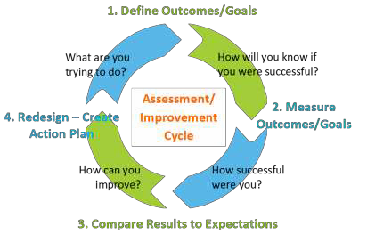

The college’s institutional assessment process begins with the submission of annual reports by all programs. They are analyzed by the appropriate senior leadership team member and at the institutional level by the Curriculum Review Committee and the Executive Board. The process includes the creation of this Institutional Effectiveness Report, which documents actions and summarizes the effects of those actions as they relate to strategic, budget, and master plans and the achievement of the institutional mission. The Institutional Effectiveness Report is the foundation for making evidenced-based decisions during strategic, operational, facility and financial planning, and a catalyst for ongoing continuous improvement efforts.

Institutional Accomplishments for FY 2019
Strategic Goals and College Priorities
The current strategic plan (SP) was developed during the summer and early fall of 2018. The Strategic Plan Taskforce developed measures for each goal. Two quarterly reports captured baseline data and progress on the goals during the third and fourth quarters of fiscal year 2018. The quarterly reports are online at http://college.gather4him.net. The measures and summaries of progress are included in this section.
This section also includes progress summaries for all activities that are College Priorities (CP). College Priorities associated with a strategic goal are reported with the goal and produce action projects. Action projects and reports progress to the Academic Committee and Board. These action projects demonstrate the college’s efforts to improve institutional performance and are evidence for the TRACS Criteria for Accreditation. Once a project is completed, the the institution will simply begin another, using the knowledge and skills gained from its earlier projects to select, shape, and define the scope of new activities. Although a college priority may end, the resulting processes, products, and structures become integral to the college.

Academics
We will establish full national academic and accreditation status.
Measures: Candidate, Category 1 status with TRACS attained in October 2018.
Self-Study for full accreditation is underway.

Retention and Completion Rates
Percentage of students who complete our program and transfer to a 4-year college or University. The transfer-out rate is based on 3 years of attendance that equates to 150% of our program and is calculated by taking the number of transfer-out students divided by the number of students who began the program at the same time. Baseline: 42.25% for the cohort beginning in fall 2015.
Retention – fall to fall for all full-time students.
- 2018-2019 Retention Rates: 64%
- 2017-2018 Retention Rates: 65%
- 2016-2017 Retention Rates: 76%
- 2015-2016 Retention Rates: 59%
- 2014-2015 Retention Rate: 79%
Composite Full Time Retention Rates: 69.75%
Completion Rates:
- 2012: 50%
- 2013: 67%
- 2014: 42%
- 2015: 30%
- 2016: 57%
NOTE: Due to the small student body, changes in completion rates can be grossly distorted by two or more additions or deletions, leaving any composite rate unreliable.
Transfer Rates (In lieu of Job Placement Rates): Percentage of students who advance to a four-year university after completion of the G4H program. Baseline: 91% of all graduates (44 graduates, 41 transfer).
Number of students who receive alternate credit. Baselines not identified.
- Prior Learning Assessment.
- College Level Examination Program, CLEP
- Advanced Placement, AP 2
- International Baccalaureate 1
- Proficiency exam
- Military Service
Number of active partnerships with four-year institutions. Baseline identified in FY16:
- Articulation agreements (7)
- Two new articulation agreements in process

Faculty Initiative to Improve Retention and Completion Action Project
The goal is to improve the ability of G4H students to identify their individual goals and to persist in reaching those goals. Approximately one-half of all G4H students are the first generation of their families to attend college, a majority come from families with a limited ability to pay for college, and fully one half of the students identify as Hispanic. Nationally, only 27 percent of first-generation students complete a degree program in the normal time frame, and 50 percent complete a program in 150 percent of the normal program time. (Source: Chronicle of Higher Education). The faculty have developed a fast-response reporting system to intervene with students who show signs of failure. The college has created a more intense social networking system to bring the Hispanic students into the mainstream of college life and writing and math tutoring projects have begun. This will help faculty help students persist and complete degrees at G4H.

Student Course Evaluations and Student Satisfaction Surveys
Once here, students have a very positive attitude toward G4H. The challenge is to convey that positive attitude to potential students, the high schools, parents and the community.
More than 75 percent commented positively upon both faculty and course content, indicating they feel they are getting a good quality education. A typical and repeated comment is to the effect that “my instructors actually care about me!”
Of particular and perhaps unexpected significance is the clearly positive reaction from students who are asked to participate in focus groups. Students appear very impressed that the College is seeking their input and is interested in their views.
The most significant negative is the lack of student awareness regarding requirements for transferring to a four-year institution.
End of Semester Course Evaluations: We now have three and a half full years of course evaluations.

Semester | Excellent % | Very Good % | Good % | Fair % | Poor %
Fall 2015 | 31.1% | 30.4% | 27% | 3.5% | 0%
Spring 2016 | 57.5% | 28.3% | 13.3% | 0.9% | 0%
Fall 2016 | 44.7% | 28.2% | 18.4% | 7.8% | 1%
Spring 2017 | 43% | 20.4% | 22.6% | 12.9% | 1.1%
Fall 2017 | 48.7% | 35.0% | 14.5% | 0.9% | 0.9%
Spring 2018 | 47.5% | 29.7% | 14.9% | 5.0% | 3%
Fall 2018 | 53.3% | 30.0% | 11.37% | 2.8% | 2%
Spring 2019 | 53.1% | 17.5% | 23.1% | 4.2% | 2.1%
Averages | 47.4% | 21.7% | 18.1% | 4.75% | 1.26%
Overall, the student course and instructor evaluations have presented a highly positive student view of the courses offered and the instructors teaching them. The percentage of students rating their courses and instructors as very good to excellent over the past eight semesters is 69.1%.
Anomalies: It is not known why the fair/poor category spiked at 14% in the spring of 2017.
Daily Average Attendance: 87.8 percent
Mean Grade Point Average by Academic Year
2015-2016 = 2.674
2016-2017 = 2.6
2017-2018 = 2.519
2018-2019 = 2.83

Percentage of graduates accepted by a four-year college or university = 96%
Declared majors include Pre-Med, Pre-Law, Teacher Education, Business, International Relations, Organizational Development, Organizational Psychology.

Alumni Satisfaction

Alumni Surveys (NOTE: These data do not accurately reflect the college in all aspects due to the low number of responses N=9)
- 77.8% of respondents went on to a four-year university
- 22.2% did not
- 11.1% have attained a BA
- 66.7% are currently enrolled in a BA/BS program
- 28.6% report that G4H prepared them “very well” for university.
- 14.3% report that G4H prepared them “More than adequately” for university.
- 57.1% report that G4H prepared them “adequately” for university
- 11.1% were “very satisfied” with the overall educational experience at G4H.
- 77.8% were “satisfied” with the overall educational experience at G4H.
- 11.1% were “dissatisfied” with the overall educational experience at G4H.
- 77.8% would enroll again at G4H to begin their college experience.
- 88.9% would recommend G4H to others.
Trends:
- 100% report that G4H prepared them adequately or better than adequately for the four-year university experience.
- 89.9% were satisfied or very satisfied with the G4H educational experience.
- 88.9% would recommend G4H to others.

Strategic Goals 2019

Strategic Goal 1: Accreditation
We will establish full national academic and accreditation status.
Measures:
- Achieved TRACS Candidate, Category 1 Status, October 2018.
- Comprehensive Self-Assessment Plan revised. Completed.
- Self-Study is underway. Target completion date: December 15, 2019.
- Successfully complete second TRACS onsite team visit. Target date: Early 2020.
- Achieve full accreditation. Target date: Fall 2020 or Spring 2021.

Strategic Goal 2: Student Enrollment
We will continue to grow our enrollment and strengthen student life programs.
Measures:
- Enrollment growth
- Year-to-year Retention Rates
- Completion Rates
- Transfers to four-year institutions.
- Focus groups
- Student satisfaction surveys
- Alumni surveys

Strategic Goal 3: Faculty and Staff
We will make appropriate additions of qualified members to the faculty and staff.
Measures:
- All faculty will have a master’s degree or higher in their selected teaching fields or a closely related field of study.
- All faculty participate in a 360° review each year. Such reviews include student evaluations, self-evaluations, observation and evaluation by the Dean of Academics.
- The college is developing a comprehensive professional development program designed to improve instructor effectiveness in conjunction with the faculty.
- The college will budget increasing amounts for faculty salaries and benefits.
- The college will actively seek and recruit highly qualified faculty.

Strategic Goal 4: Financial Sustainability
We will gain financial sustainability by implementing a long-term business plan.
Measures:
- Federal Financial Aid for Students (Title IV): Achieved September 2019.
- Number of marketing events and campaigns will be increased.
- Tuition is gradually being increased.
- Complete qualification for Federal Financial Assistance.
- Seek and secure endowments.
- Newsletter
- Face-to-face recruiting at schools
- Faculty/Staff speaking engagements at schools

Strategic Goal 5: Campus Facilities
We will secure financing and develop our new campus facilities in Kennewick, Washington.
The college Board and Administration are actively planning a new, much larger and more effective campus.
Measures:
- Agreement to purchase 5 acres of land
- Architectural drawings of new facilities
- Capital campaign beginning November 2019.

Strategic Goal 6: Information TECHNOLOGY
We will add and utilize the technology necessary for a growing student body.
Measures:
- Informational Technology audit by outside vendor.
- Secure $50,000 matching grant for technology improvement. Total: $100,000
- Acquisition and operation of new computer technologies to include all new administrative computers, WiFi and broadband secure intranet and internet systems; acquisition of a new phone system, acquisition of laptop and tablet computers for student use.
- Establish a computer literacy lab for student and faculty use.

Strategic Goal 7: Board Governance
We will implement professionally led board building strategies.
Measures:
- Board retreat to clarify roles, goals and expectations
- Facilitated governance growth processes
- External analysis and recommendations for Board processes.

ACCOMPLISHMENTS
This section recognizes the measurable impacts/significant contributions by individual divisions.

Academic Affairs
Significant contributions to the institution during the past year include:
- Addition of the ALEKS computerized mathematics tutoring system for student use.
- Testing and remediation for students with mathematics disability (Dyscalculia).
- Strengthening ties to local churches and high schools.
- The cumulative Grade Point Average (GPS) is rising.
- Implementation of Student Academic Early Intervention Program.
- Addition of ACCUPLACER Ability to Benefit testing for students with no recognized secondary education certificate.

Administrative Services
Significant contributions to the institution during the past year include:
- Added of a Financial Aid Administrator and Recruiting Specialist
- Contracted with FA Solutions to provide processing of student financial data.
- Contracted with OCLC WorldShare for interlibrary loans.

Communication and External Relations
Significant contributions to the institution during the past year include:
- New Direct Transfer Agreements in negotiations or in place with two more four-year institutions.

Human Resources
Significant contributions to the institution during the past year include: Designed and implementing a program of professional development for instructors, administrators and staff.

Information Technology
Significant contributions to the institution during the past year include:
- Increased WiFi connectivity for staff and students.
- Received bids on an entirely new information technology system
- Activated the Library including digital student services.
- Accessed OCLC Worldshare Interlibrary Loan Program

Institutional Research and Effectiveness
Significant contributions to the institution during the past year include:
- Completed the Revised Comprehensive Self-Assessment Plan,
- Completion of the first Self-Study,
- Ongoing research and implementation of student success strategies in academics.
- Added three new adjunct faculty

Student Development
Significant contributions to the institution during the past year include:
- Expanded Student Ambassador program
- Expanded Student Practicum experience
- Expanded Student Advisory Board
- Expanded student activity opportunities
- Ability of students to pursue materials through interlibrary loans (OCLC Worldshare).

Institutional Issues of Note
The Strategic Five-year Strategic Plan is modified each year based on the following data: Student enrollment, student retention and completion rates, student satisfaction rates, financial realities, facility and technological needs, faculty evaluations and satisfaction rates, and other relevant information.
The College is embarking on creating a new, larger campus that will serve up to 400 students in the Southridge Area.
The Team did feel it was important to note the following issues presented in alphabetical order:
Adjunct Faculty – The college is seeking high quality adjunct instructors. The issue is compounded by lack of qualified candidates and the need to improve hiring and training processes of adjuncts.
- Three new fully qualified adjunct faculty were added between January and August 2019.
Class Sizes – The large number of students in the entering cohort created larger class sizes than we would like in Sociology/ Psychology and College Writing 1.
- We were able to hire a second Social Sciences instructor, splitting the class of 30 into 2 sections of 15.
- We were unable to hire a second College Writing instructor, leaving College Writing 1 with 26 students.
Entering students continue to be under-prepared in study habits, time management skills, and mathematics. Note: The incoming 2018 class scored higher in mathematics than any previous class and the number of students requiring remedial mathematics is dropping.
- The Fall 2019 incoming cohort had the highest scores in mathematics that we have seen.
High Number of College Priorities – The College currently has a large number of priorities (goals, accreditation projects, plans, grants, financial assistance, etc.) in progress. This puts a strain on people and resources, which threatens timely, high-quality achievement.
Staffing and Responsibilities – Institutional and program initiatives and reporting, inadequate data tools, the small number of staff, and the unusually broad scope of the current initiatives and requirements is placing a long-term untenable workload on administrators.
Student Population – The population of Hispanic students enrolled at G4H has surpassed 50 percent, which may qualify the college for federal funds as a Hispanic-serving institution (HSI). Federal funding can be used to assist first generation, majority low-income Hispanic students.
Technology Systems – The current technology systems, particularly computers, are old and obsolete, and need to be replaced. A technology replacement plan has been developed and out for bid.

Institutional Effectiveness
Institutional effectiveness involves collecting, analyzing, and sharing institutional data for statutory reporting and continued institutional improvement. The types of indicators being considered include the following:
Performance Indicators (or Key Performance Indicators) – An evaluation of performance based upon agreed upon indicators of quality and comparisons with other institutions. Performance indicators are generally more externally mandated to meet accountability demands from state, federal, and accreditation agencies.
Effectiveness Indicators – An evaluation of what colleges should be doing by assessing whether the college is doing what it says it is doing. While performance indicators are more superficial and only incidentally linked to mission, effectiveness indicators are generally more tied to mission and goals. Effectiveness indicators are generally internally driven.
Diagnostic Indicators – Diagnostic indicators do not generally provide evidence of success in meeting organizational goals or accountability demands but are focused on indicators of organizational health that could impact performance or effectiveness. Diagnostic indicators generally cover financial stability or student satisfaction.

Institutional Action Plan

TRACS Accreditation
The TRACS accreditation pathway is focused on quality assurance and institutional improvement with an added emphasis on helping institutions achieve continuous quality improvement. The TRACS pathway follows a five-year cycle. The five-year cycle includes the following institutional reviews:
Annual Institutional Update – Reviewed by TRACS to monitor organizational health, comply with educational requirements and identify any changes that may require TRACS follow up.
During each year of the cycle, institutions submit Action Plans for review. The primary foci are student learning and institutional financial stability.
Comprehensive Reaccreditation Review in Year 5 – At the end of the five-year cycle, institutions undergo a Comprehensive Reaccreditation Review pursuing institutional improvement and complying with certain requirements set by TRACS and the U.S. Department of Education. This review leads to an action regarding the reaffirmation of the institution’s accreditation.

Strategic Goals and College Priorities
The following activities relate to the strategic plan goals and college priorities. They are subject to budget allocation and funding approval. Senior leaders will determine the order of implementation.
Strategic Goal 1: We will establish full national academic and accreditation status.
College Priority: Complete Self Study by March 2020.
Submit Self-Study. Target date: March 2020.
Strategic Goal 2: We will continue to grow our enrollment and strengthen student life programs.
College Priority: Faculty Initiative to Improve Retention and Completion. Projected completion is April 2019.
- Progressive Pathways to Student Success – Projected completion is 2020. Academic Affairs, Student Life and Faculty will work cohesively to execute projects that improve our ability to serve oue students and to do so more effectively.
- Student Development – Further automate admissions processes and degree audits.
Strategic Goal 3: We will make appropriate additions of qualified members to the faculty and staff.
College Priority: Increase faculty pay
Create a pool of faculty candidates.
Strategic Goal 4: We will gain financial sustainability by implementing a long-term business plan.
College Priority: Achieve Federal Financial Aid for Students (Title IV): Achieved.
Increase amounts of tuition received.
Grow and stabilize regular monthly donors.
Strategic Goal 5: We will develop our own campus facilities in Kennewick, Washington.
College Priority: Develop and implement capital campaign for new facilities.
Strategic Goal 6: We will add and utilize the technology necessary for a growing student body.
College Priority: Achieve $50,000 matching grant for technology from the Murdoch Foundation, purchase and install new technology.
Strategic Goal 7: We will implement professionally led board building strategies.
College Priority: Continue board development processes with outside facilitator.

Requests fir Additional Resources
The activities and initiatives proposed for future years may require additional resources such as personnel, equipment, technology, and/or facilities. The college president and senior leaders use budgeting requests to inform future financial and facility planning.
We estimate that we will outgrow the current facility within the next four years.

Future Academic Goals
- Achieve full accreditation
- Expand the science program and facilities.
- Expand the curriculum.
- Add Online courses.
- Increase the number of Direct Transfer Agreements.
- Add a second curricular program.

